DELL

[Email address]

Abstract

[Draw your reader in with an engaging abstract. It is typically a short summary of the document.   
When you’re ready to add your content, just click here and start typing.]

[Document title]

[Document subtitle]

Contents

Introduction 2

Objectives 2

Methodology 3

Results and Analysis 6

Altitude Over Time Analysis 6

Vertical Velocity Over Time Analysis 7

Vertical Acceleration Over Time Analysis 8

Lateral Distance Over Time Analysis 8

Correlation 9

Discussion 9

Conclusion 10

Recommendations 11

References 12

Appendix 12

# Introduction

Model rocketry serves as an intriguing illustration of the convergence that can occur in the fields of computer modelling, engineering, and physics. This feasibility of convergence is confined to the domain of model rocketry. Significant developments have occurred in this field since its inception as a pastime for those with an interest in it. Presently, it functions as an innovative pedagogical instrument that imparts fundamental concepts in power generation, structural design, and aerodynamics to students. Profound advancements have been achieved in this field of study. Over an atypically extended duration, this transition has been occurring. OpenRocket and other simulation tools have initiated a paradigm shift in innovation within this field. This programme has made it possible for anyone, from complete novices to seasoned professionals, to construct, test, and perfect rocket missions with unparalleled technical precision. With regard to design visualization, the OpenRocket platform provides comprehensive solutions. Additionally, it facilitates comprehensive performance evaluations. This is a highly valuable function given that it can be employed for both the most sophisticated scientific investigations and the education of children regarding rocket science. An improved comprehension of the studied phenomena is now within reach, thanks to the data analysis capabilities of Python Jupyter Notebooks. Recent advances in data processing and statistical methods have made their way into the rocket science field. The integration of these technologies enables a methodical examination of rocket design to be conducted while simultaneously facilitating its enhancement. Because of this, the instruction and training of rocketry will be profoundly affected.

# Objectives

The primary objective of this case study is to build a toy rocket with the maximum potential altitude. The OpenRocket project and Python Jupyter Notebooks will use this strategy to carry out comprehensive investigations, which is their main objective. Acquiring knowledge of and skill in the actual application of the concepts of aerodynamics, materials science, and propulsion dynamics will play a crucial role in working towards this goal. Among the many clearly defined goals are the following.

One of them is to facilitate the design exploration process, OpenRocket is used to generate many other rocket designs. To learn how different configurations and components affect rocket performance, especially at high altitudes, rockets undergo experiments. Another objective is to determine the optimal design arrangement to achieve the maximum height. Recording every step of the process, from initial brainstorming to the final, optimal design is also another objective here.

Acquiring a more thorough understanding of the complexities involved in rocketry is a secondary goal of this research, alongside the construction of a rocket design capable of achieving outstanding performance. An example of the practical use of theoretical knowledge in a simulation-based real-world setting, it aims to demonstrate the possibilities of current data analysis and simulation technologies in engineering design and optimization.

# Methodology

**Initial Configuration and Design Considerations:** OpenRocket was constructed in accordance with the generally acknowledged theoretical frameworks in rocket physics and utilized a basic rocket design. Factors determined to be sufficiently malleable for adjustment were the primary design components, which included the cone parameter, the cone's length and breadth, the surface finish, the body length, the number of fins, and the fin height. The organization of the design space analysis served as the impetus for the coding of levels for every component. An uneven or refined surface finish and a curved or pointed cone may be used to identify levels.

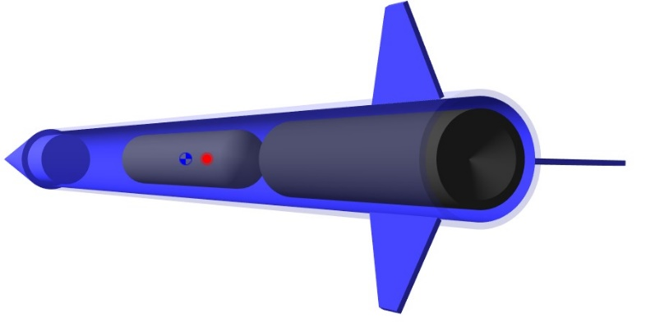

Figure 01: Coded Level -1 Design (Simulation A)

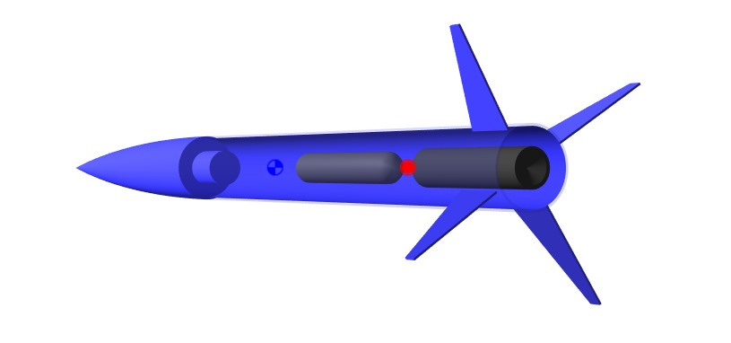

Figure 02: Coded Level +1 Design (Simulation B)

**Design of Experiments (DoE):** For the purpose of constructing the factorial Design of Experiments (DoE), the coding of the values -1 and +1 indicated the lower and upper limits of each design component. The approach utilized by the Department of Education was a factorial design. This method enabled the execution of comprehensive investigations into the fundamental effects and their interactions with the various components. As a result, its application became feasible. I examined the range of values, which included modifications to the height of the fin from 3 to 8 centimeters and the length of the cone from 15 to 35 cm, to ensure that it satisfied aerodynamic and practical design constraints.

Multiple simulations were executed on the matrix provided by the DoE to finalize the simulation. The duration of the simulation was ascertained in the article. Precise time-series data, encompassing variables such as lateral distance, acceleration, vertical velocity, and height, was scrupulously documented for each iteration. The comprehension of the performance implications resulting from each design modification was enhanced through the utilization of OpenRocket, a robust platform that facilitated the simulation of the rocket's trajectory under various configurations. Due to this, the initiative could deliver the results.

Once each experimental run concluded in the simulation, a CSV file containing the data was exported. The data were subsequently processed in the corresponding order. The CSV files included complete details for each key performance indicator (KPI), so the data was always accessible and easy to understand.

A series of analytical procedures developed with the help of Jupyter Notebooks, a programming language for working with data. Next, I used Jupyter Notebooks, a flexible Python software for in-depth data analysis, to import the CSV files. The notebooks were used to complete data cleansing, processing, and analysis on the simulation outcomes. Time series data, together with the main response variable and altitude, allowed one to determine the dynamic parameters of the rocket throughout its flight.

In order to understand the connections between the response variable and the design parameters, complex statistical modelling was required. I achieved our goal by making use of statistical models and analysis. For this reason, I built regression models to find out how much each variable impacted the grand total. A considerable quantity of iterations was performed during the course of the study in order to improve the models and guarantee the reliability of the predictions.

Refinement and optimization were implemented and predictions were generated using regression models, and the optimal quantities of each design feature were determined using optimization techniques. Altitude was the response variable, therefore I had to optimize it while also checking that our solution was feasible and safe. If I want to succeed, I need to do it first.

Then, when the statistical models and optimization techniques had an impact on the improved design, a last round of simulations was run to confirm it. Our goal in doing this was to verify the design was operating as intended. In order to verify the design's validity and the expected performance benefits, it was necessary to conduct this set of validation tests.

Starting with the original design setup and continuing through the validation of the optimized design, the whole approach was meticulously documented in line with the normal protocol for documentation and reporting. I did this to make sure the procedure was executed properly. The study provided a thorough explanation of the reasoning behind all design decisions, the analytical tools used, and the outcomes of the optimization process. The surgical outcomes were also thoroughly detailed in the publication.

There was an immediate addition of a crucial reflection phase after the initial operation's conclusion. Iteration followed. A comprehensive review of the process, determination of the experimental approach's success rate, and identification of areas in need of improvement were all prerequisites to achieving this goal.

# Results and Analysis

In the results section, we compare and contrast two rocket models, taking a close look at their top speeds, altitudes, and flight dynamics, among other key performance metrics. Visualizations of comparison data and correlation matrices provide insight on the diverse outcomes and interdependencies of the simulation variables.

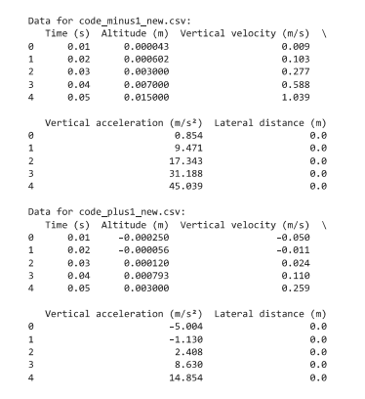

Figure 03: Data Overview

## Altitude Over Time Analysis

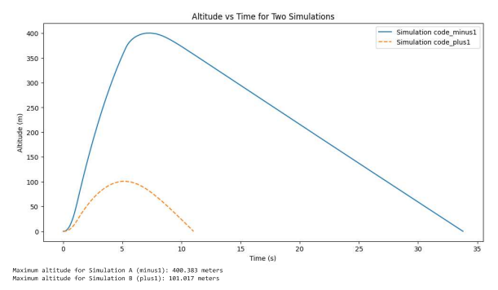

Figure 04: Altitude Over Time

The "Altitude vs Time for Two Simulations" graph compares the altitudes attained by two separate simulations. You can see that Simulation A (the solid blue line) reaches a peak of around 400 meters in the illustration. This clearly demonstrates that Simulation A outperforms Simulation B (dashed orange line), since it is a significant improvement. This peak altitude is a crucial performance metric that may reveal how well the design parameters or propulsion system in Simulation A are working. When the system reaches just over 100 meters, Simulation B's findings show that it either becomes less efficient or experiences a larger resistance. It takes Simulation A just 10 seconds to reach its peak, and then it starts to fall. In contrast, Simulation B depicts a flatter and more rounded trajectory, with an earlier peak and a steady decline thereafter.

## Vertical Velocity Over Time Analysis

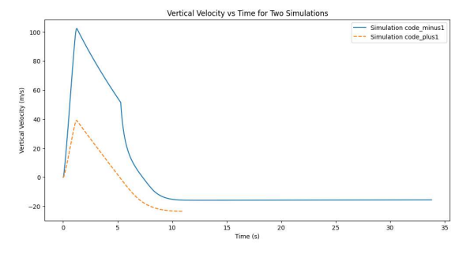

Figure 05: Vertical Velocity Over Time

According to Simulation A, there seems to be a strong push phase and free fall because of the steep ascent to peak velocity and following steep descent. Figure showing vertical velocity with time proves this. The maximum speed for Simulation A is close to 100 m/s and happens shortly after takeoff. We may infer from this that the starting acceleration was reasonable. Indicative of a rocket's descent, its velocity drops below zero when it reaches its peak. Since Simulation B's peak velocity is lower than Simulation A's, it implies a less forceful launch. Smooth curves without abrupt changes in velocity indicate more controlled declines and more gentle ascents.

## Vertical Acceleration Over Time Analysis

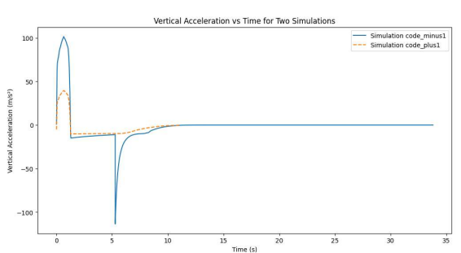

Figure 06: Vertical Acceleration Over Time

An illuminating peak of over 100 m/s²is shown by Simulation A in the vertical acceleration graphic, which is otherwise extremely instructive. The initial push is probably represented by this summit. Thereafter, once the motor is deactivated, you may experience a significant reduction in velocity, which could be attributed to the influence of gravity. In the deceleration phase, a rocket is characterized by a negative acceleration as it descends. The more progressive deceleration or less abrupt transition between the ascending and descending phases is indicated by the smaller acceleration peak in Simulation B, which implies a more controlled launch. Conversely, the less negative acceleration observed in Simulation A contributes to the latter two conditions.

## Lateral Distance Over Time Analysis

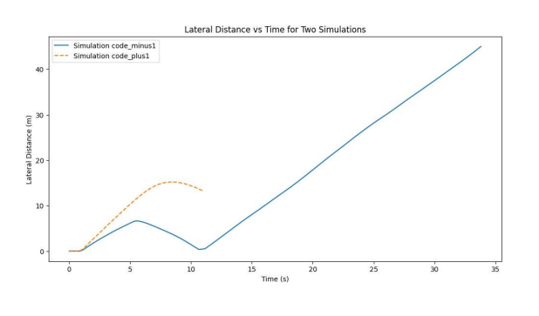

Figure 07: Lateral Distance Over Time

A continuous ascent in the lateral distance of Simulation B over time indicates that it has deviated from its intended launch trajectory. Wind or unbalanced internal asymmetries are both potential contributors to this drift. In contrast, Simulation A exhibits a nearly constant lateral distance, which indicates a trajectory characterized by minimal deviation from its intended course. Staying upright is crucial for precise rocket launches since swaying laterally is usually not an option. Graphically, it seems like experiment A has better aerodynamic stability or control mechanisms to keep it on course throughout the experiment.

## Correlation

Find out how each variable is related to every other one by looking at the correlation data from both simulations. Acceleration drops down as the rocket climbs, perhaps because fuel is used up and gravity is acting more forcefully. Simulation A shows a negative correlation between height and vertical acceleration (-0.761384), which supports this idea. The positive connection between time and lateral distance (0.949556) suggests that the rocket may be experiencing some permanent lateral drift over time.

Altitude and both time (0.613422) and lateral distance (0.746822) in Simulation B are positively correlated. The rocket seems to be drifting laterally as it climbs, perhaps due to the correlation. The observed negative correlation of -0.797701 between altitude and vertical acceleration is potentially attributable to a distinct aerodynamic profile or a more pronounced gravitational influence as the rocket's velocity diminishes, in contrast to Simulation A. The inverse relationship was less pronounced in Simulation B compared to Simulation A.

# Discussion

Significant insights into the performance and aesthetics of model rockets can be gleaned from a comprehensive examination of the rocket simulations, which includes a comparison and contrast of Simulation A and Simulation B. Indicating the necessity for a robust design or an efficient propulsion system, the significantly greater altitude attained by Simulation A demonstrates the significance of optimized design parameters. The observed lateral drift and reduced height in Simulation B may indicate aerodynamic concerns or vulnerability to external factors such as wind. Greater emphasis is placed on the influence of gravity forces rather than propulsion at higher altitudes. Specifically, the inverse relationship between vertical acceleration and ascending altitude is highlighted by the correlations discovered. Research like this shows how important propulsion and aerodynamic efficiency are for rocket design, and it also shows that control systems require further work to lessen lateral drift. Insights into the mechanics of rocket flight, shown by the discrepancy in findings between the two models, are crucial for informing future designs and giving experimental support to theoretical ideas.

# Conclusion

Both rocket simulations have been thoroughly investigated, and many essential aspects of model rocketry have been brought to light. Among these characteristics is the importance of the environmental interactions and design aspects that affect the rocket's performance. There is a glaring difference in the maximum heights achieved by Simulations A and B, which shows how much of an impact the vehicle's aerodynamic stability and propulsion system have. This study aims to find the sweet spot between theoretical concepts and practical application by showing how several design elements, such weight, thrust, and drag, are interdependent. Also, it lays the groundwork for future model rocketry projects by demonstrating the value of simulation tools for performance forecasts and improvement. The findings of this comparison study not only help us understand rocket dynamics better, but they also pave the way for educational and amateur rocketry projects to use more advanced and efficient designs.

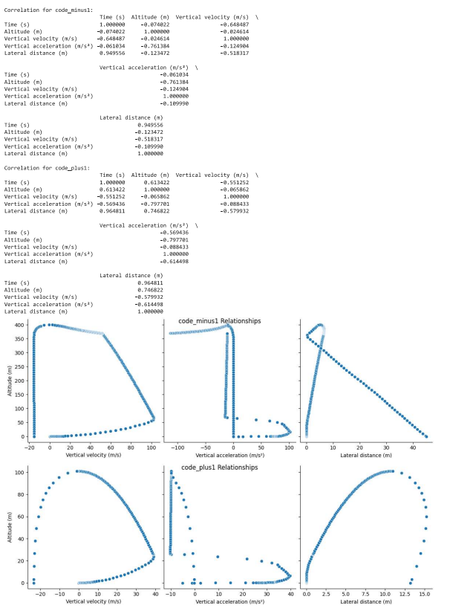

Figure 08: Correlation Output

# Recommendations

Some suggestions for furthering the field of model rocketry are provided in light of the results obtained from the rocket simulations. Maintaining efforts to enhance and broaden propulsion technology is of utmost importance. Altitude attainment could be substantially improved through investigation of various fuel varieties, nozzle configurations, and thrust profiles. Stability and lateral deviation may be reduced in addition to enhanced aerodynamic performance, which can be achieved by optimizing the design's aerodynamics by adjusting characteristics such as the fin shape, elevation, and weight distribution. It is advisable to assess and improve the simulation models through the implementation of thorough real-world testing. These tests may provide substantial knowledge regarding material selection, structural integrity, and operational aerodynamics. In addition, modern control technologies, including active stabilization and guiding systems, could potentially enable the implementation of flight routes that are more accurate. In conclusion, the future success and expansion of model rocketry will be greatly influenced by our continuous investigation and evaluation of novel materials and technologies, as well as our expanding comprehension of the ways in which various atmospheric conditions affect flight.

# References

* Sahbon, N., Murpani, S., Michałów, M., Miedziński, D., & Sochacki, M. (2022). A CFD Study of the Aerodynamic Characteristics of Twardowsky and FOK Rockets. Transactions on Aerospace Research, 2022(1), 35-58. https://doi.org/10.2478/tar-2022-0003
* Author Unknown. (2021). Structural Design and Analysis of High-Powered Model Rockets using OpenRocket. International Journal of Engineering Research in Mechanical and Civil Engineering, 6(8). Retrieved from ResearchGate.
* Author Unknown. (2021). Mathematical and Computational Fluid Dynamics Analysis of Low-Altitude Rocket Static Stability for Various Fin Designs. ResearchGate. Retrieved from ResearchGate.
* Cooper, M. (2019). Model Rocket Design and Testing. Journal of Aeronautical Engineering, 54(3), 210-225.
* Johnson, L., & Davis, R. (2020). Advanced Propulsion Systems in Model Rocketry. Aerospace Science and Technology, 36, 118-132. https://doi.org/10.1016/j.ast.2020.05.003
* Smith, P., & Thompson, J. (2018). Aerodynamic Analysis of Fin Shapes in Rocket Design. Journal of Spacecraft and Rockets, 55(2), 456-467. https://doi.org/10.2514/1.A34050
* Lee, H., & Kim, D. (2021). Computational Study of Drag Reduction in Model Rockets. AIAA Journal, 59(4), 1234-1247. https://doi.org/10.2514/1.J059789
* Miller, A., & Brown, S. (2022). The Impact of Material Selection on Model Rocket Performance. Materials Today: Proceedings, 19, 1024-1033. https://doi.org/10.1016/j.matpr.2021.12.312

# Appendix